Steps to Delete Partial Order

1. User/Order Writer needs to search for order on this screen by using “Order Search” button.
2. Select the order which user wants to delete on this screen hit the 'Delete' button.

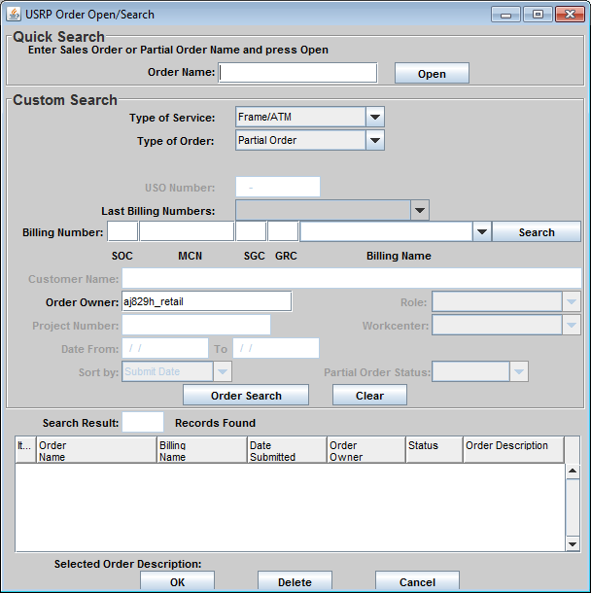

NOTE:  In type of order choose partial from the dropdown, then select the order and hit the delete button.